**DAILY ONLINE ACTIVITIES SUMMARY**

|  |  |  |  |  |  |  |  |  |
| --- | --- | --- | --- | --- | --- | --- | --- | --- |
| **Date:** | **31-05-2020** | | | | | **Name:** | **Kanaka BS** | |
| **Sem & Sec** | **6th A** | | | | | **USN:** | **4AL17CS039** | |
| **Online Test Summary** | | | | | | | | |
| **Subject** | |  | | | | | | |
| **Max. Marks** | |  | | **Score** | | |  | |
| **Certification Course Summary** | | | | | | | | |
| **Course** | **Step into Robotic Process Automation(RPA)** | | | | | | | |
| **Certificate Provider** | | | **GUVI** | | **Duration** | | | **3 hrs** |
| **Coding Challenges** | | | | | | | | |
| **Problem Statement:** | | | | | | | | |
| **Status:** | | | | | | | | |
| **Uploaded the report in Github** | | | | | **YES** | | | |
| **If yes Repository name** | | | | | <https://github.com/kanakabs/Daily-Status/tree/master/31-05-20> | | | |
| **Uploaded the report in slack** | | | | | **YES** | | | |

Certification Course Details:

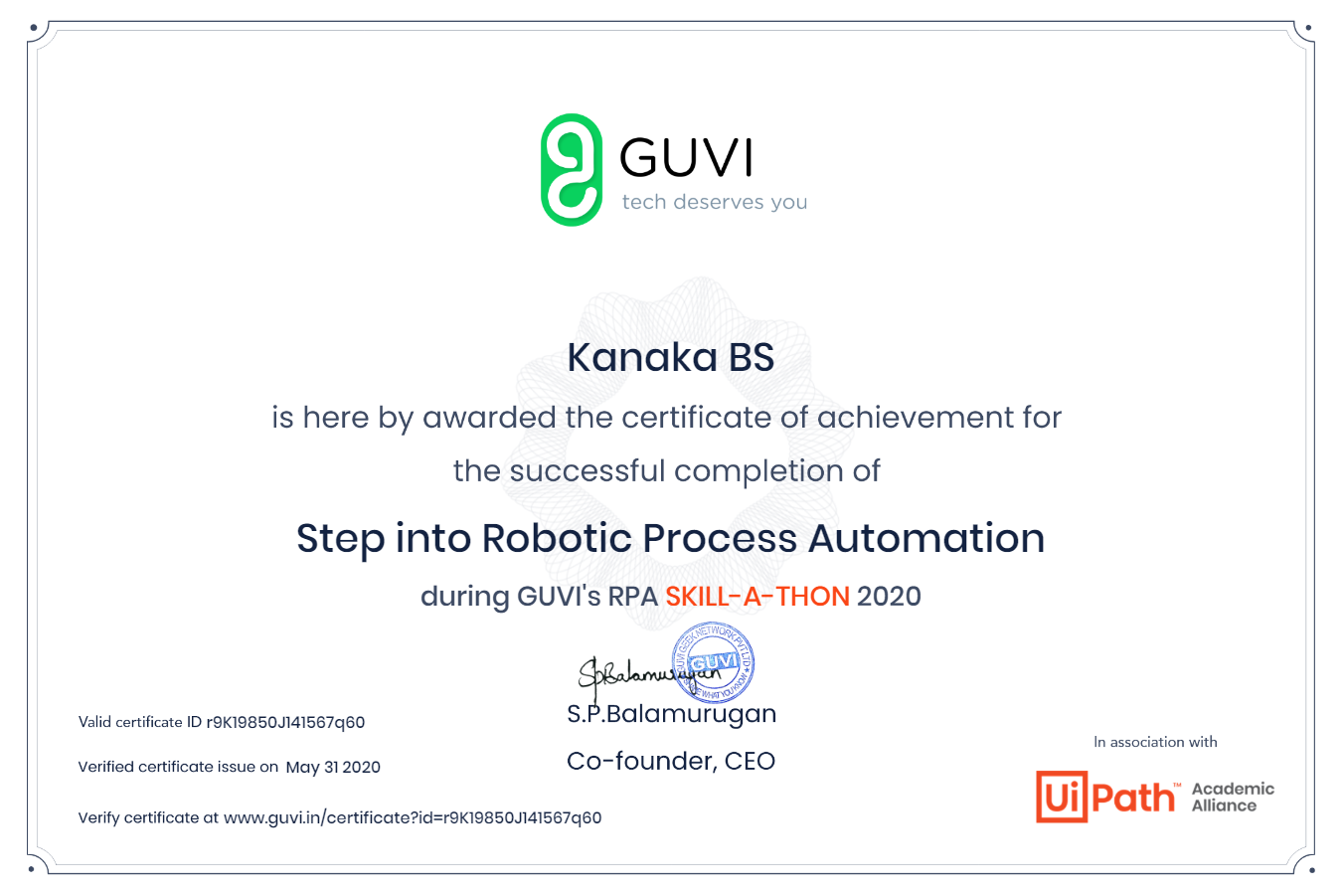

Completed Step into Robotic Process during GUVI’s RPA SKILL-A-THON 2020